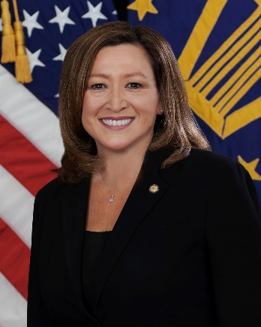
Roxanne J. Banks
DLA Acquisition, J7
Defense Logistics Agency
Fort Belvoir, Virginia

Ms. Roxanne J. Banks currently serves as Deputy Director of Acquisition (J7) Defense Logistics Agency, Fort Belvoir, VA. She is responsible for the development, application, and oversight of DLA acquisition policy, plans, programs, functional systems and operations for the annual Agency acquisition program exceeding $35 billion. In addition, she serves as Head of Contracting Activity for DLA’s Distribution, Disposition, Strategic Materials, Joint Contingency Acquisition Support Office and DLA’s Contracting Support Office. As Senior Services Manager, she oversees a portfolio exceeding $2 billion and is responsible for establishing appropriate management structures and processes to ensure effective validation and execution of the acquisition of services for DLA.
Ms. Banks has been a member of the Senior Executive Service since 2013 when she joined the Small Business Administration as their Director of the Denver Finance Center (DFC). While at DFC, Ms. Banks provided oversight of SBA’s financial management operations and served as Senior Procurement Executive for contract execution of internal requirements.
Ms. Banks attended the College of Santa Fe, Santa Fe, New Mexico, from which she received a Bachelor of Arts in Business Administration. She completed her postgraduate education at St. Mary’s University in San Antonio, Texas, where she received a Master’s in Business Administration. She also holds a Master of Science in National Resource Strategy from the Industrial College of the Armed Forces, Ft. McNair, Washington, DC.
Ms. Banks started her acquisition career in 1989 as an Air Force Copper Cap Intern at the Aeronautical Systems Center, Wright-Patterson AFB, Dayton, Ohio. She went on to serve in numerous Air Force acquisition assignments with increasing levels of responsibility at the Human Systems Center, Brooks AFB, Texas; the Space and Missile Systems Center, Detachment 12, and the Air Force Inspection Agency, both at Kirtland AFB, New Mexico; and at the Office of the Deputy Assistant Secretary (Contracting), Pentagon, Washington, DC. In 2006, Ms. Banks served as the Director of Contracting, Missile Defense Integration & Operations Center, Missile Defense Agency, Colorado Springs, Colorado.
Ms. Banks is a certified Professional Contracts Manager, a member of the Defense Acquisition Corps and is Level III certified in Contracting, and Level I certified in Program Management. She is a graduate of the Defense Systems Management College’s Advanced Program Management Course, the Defense Acquisition University’s Senior Acquisition Course and the Federal Executive Institute, Leadership for a Democratic Society.

