DLA Aviation FAJA March 2019
Subject: Minimum requirements for a cylinder to be considered for return to the wholesale supply system for refurbishment or to find an applicable NSN.
- Legibly stamped Government ownership. The cylinder shall be inspected for markings denoting Government ownership. Markings identifying government ownership are as follows: U.S. Government, U. S. GOVT, U.S. Property, WD, AF DA, USA, USN, N, US, or the name of a DoD or other government agency impressed into the shoulder of the cylinder or embossed on the neck ring. A military or federal specification number impressed into the shoulder of the cylinder will also establish government ownership.

- A legibly stamped serial number.

- A legibly stamped cylinder specification and service pressure (ex. DOT 3AA2015, DOT 4BW300, DOT 8, ICC 3AA2015, etc.).

  - DOT –Department of Transportation / ICC- Interstate Commerce Commission.
  - 3AA Specification of type and material of cylinder construction.
  - 2015 service pressure in psi.

NOTE: If a “3A” Specification, the cylinder also needs to be stamped with “NONSHATTERABLE," "NON-SHAT," or "SHATTERPROOF" or one of the following specifications IAW DLAI 4145.25 SECTION 3-2 CHARACTERISTICS OF CYLINDERS ( f ) Nonshatterable/Shatterproof Cylinders:
SPS 843 (INT)
SPS 1022 (INT)
51-C-26 and 51-C-26 (INT)
51-C-41 and 51-C-41 (INT)

Cylinders marked with specification 51-C-31 or 51-C-31 (INT) are also nonshatterable if the initial (earliest) Hydrostatic Test date is 6-44 or later.

NOTE 2: If a “3L” Specification, the cylinder is acceptable provided it meets the additional requirements.

NOTE 3: Cylinders with a π (PI) stamp need to be identified and reported.

- No external physical damage, to include: dents, holes, significant pitting, damaged/crossed threads or illegible stamping.

- Dimensions: diameter and height are measured IAW with drawing below; notice height does not include the valve or cap.

- Cylinder must have a flange or neck ring to receive the cap; exceptions are the 10 CF and 40 CF Acetylene.

- For Acetylene cylinders, the capacity (ex; CAP 225cf) and tare weight (TW) must be legibly stamped.

- Cylinders without valves and not plugged require an internal inspection for obvious physical damage that will render the cylinder unserviceable, to include damaged/crossed threads, heavy rust (light surface rust is acceptable) and pitting.
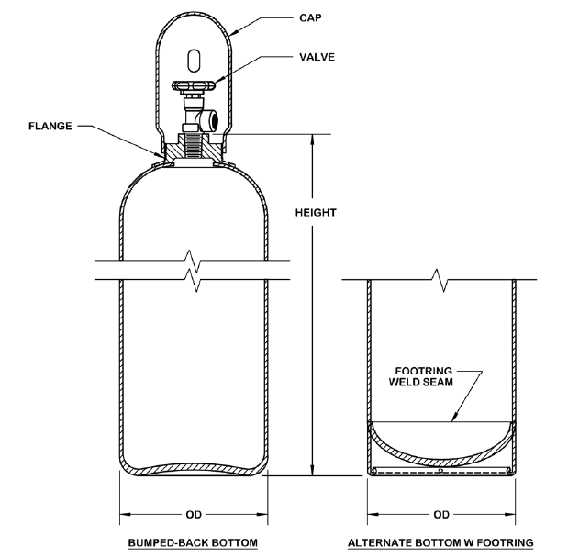
- If cylinder does not qualify for refurbishment based on the above criteria, dispose IAW DOD Joint service instruction (DLAI 4145.25, AR 700-68, NAVSUPINST 4440.128D, AFJMAN 23-227(I) and MCO 10330.2D (16Jn200) titled “Storage and Handling of Liquefied and Gaseous Compressed Gases and Their Full and Empty Cylinders”, Sections 7 & 8 DISPOSAL OF COMPRESSED GASES OR LIQUIDS IN CYLINDERS and DISPOSAL OF COMPRESSED GAS CYLINDERS.
http://www.aviation.dla.mil/ExternalWeb/UserWeb/aviationengineering/HTIS/Manuals/i4145_25.asp

Note : Cylinders with dimensions of 9”x51” and service pressure of 1800 PSI are not usable by the DLA Industrial Gas Program.

- To submit a list of excess cylinders being offered for turn-in to DLA please use the following table:
- Contact information for returns:
  - CONUS (Hudson) Cylinders: Call (800) 610-4571 or email cylreturn@hudsontech.com to coordinate Cylinder Returns and Excess Turn-ins.
  - EUCOM (IGS) Cylinders: Call (877)352-2255 or Tel (+32) 3 860 95 60
  - CENTCOM (ISS) Cylinders: KUWAIT: +965 66879860; BAHRAIN: :+973 39600859; QATAR: +974 33192165; DUBAI & DJIBOUTI: +971 505505436 or Email:- DLAGasProject@iss-shipping.com
  - OCONUS customers should turn-in empty reparable cylinders to their supporting DLA Depot under RIC SMS. Once the cylinders show as Stock-on-Hand (SOH), then disposition instructions will be issued for return of the cylinders to the Contractor.
  - CENTCOM customers should return cylinders directly to the Contractor or retrograde then back through the theater supply system based on their location.

