Cataloging Data Change (CDC) Standard Operating Procedures
Cataloging Data Standards, Enterprise Business Standards Office
Contents

Change History 3
Introduction 4
What is a Cataloging Data Change (CDC)? 4
What is the Difference between Proposed, Administrative, and Approved CDCs? 4
Why Do I Need to Submit a CDC? 4
When and How Do I Submit a Cataloging Data Change? 4
Who Can Submit a Cataloging Data Change? 5
What Information is Required on a CDC Submission? 5
Cataloging Data Change Process Overview 6
Phase One: Preparation 6
Step 1 6
Step 2 6
Step 3 6
Phrase Two: Internal Staffing 7
Step 1 7
Step 2 7
Step 3 7
Step 4 7
Phase 3: FCC Member Coordination Phase 7
Step 1 7
Step 2 8
Step 3 8
Phase 4: Approval 8
Step 1 8
Step 2 8
Step 3 8
Step 4 8
Additional Resources 8
Appendix 1: Required Fields for CDC Submission 9
Appendix 2: Administrative CDC Eligible Tables 10
Appendix 3: FCC Voting Members 12
Appendix 4: CDC Scenarios 13
Scenario #1: My Service/Agency requires a New MOE Rule 13
Service/Agency Preparation 13
Submitting the CDC to the Service/Agency FCC Voting Representative 14
FCC Leadership Review 14
EBSO Review and Internal Staffing 14
FCC Leadership Distribution 15
Scenario #1: Example ACDCs: 15

Change History

This table documents any significant changes made to the SOP. For questions or comments regarding changes, or suggestions for future content, please contact the EBSO CDS Team at: EBSO.CDS@dla.mil.

Date | Change Description | CN
12/16/19 | Established final draft of SOP. | 1

Introduction

What is a Cataloging Data Change (CDC)?
A Cataloging Data Change is the document used in the governance process for changes to Cataloging data (e.g., code lists), legacy transaction formats, and associated procedures in Cataloging Data and Transaction Standards (CDTS), Volumes 8‐13, as well as future standard Cataloging transaction formats.
Approved Cataloging Data Changes drive changes to the Federal Logistics Information System as well as the Cataloging data interchange.

What is the Difference between Proposed, Administrative, and Approved CDCs?
Proposed CDCs are changes that reflect many users and must be reviewed and coordinated by FCC Voting Members. Members then weigh in on whether they concur or non-concur with the changes.

Should members non-concur, they must provide the reason(s) for non-concurrence, and provide alternative solutions if possible.
Administrative changes:
- Affect a single service or agency and do not impact other service or agency systems other than their own and FLIS
- Correct typographical errors or changes that do not impact the data within FLIS
- Are eligible for administrative processing based upon agreement or data stewardship. Appendix 2 contains Administrative‐Eligible tables.
Approved changes can follow the Proposed or Administrative path, but are CDCs approved for implementation and publication.

Why Do I Need to Submit a CDC?
CDC Preparation Tip:
EBSO recommends verifying the CDTS Volumes affected by your CDC. Find them at:
www.dla.mil/EBSO-Cataloging-Pubs
The CDC acts as a historical record, documenting the how and why of changes to FLIS. Since changes to Volumes 10‐13 drive changes to FLIS, no changes are approved without a completed CDC.
This protects the integrity of the data and ensures all affected parties are aware, with ample time to prepare for possible impacts.

When and How Do I Submit a Cataloging Data Change?
Anytime a Service/Agency identifies necessary changes to:
- Data within CDTS Volumes 8‐13 and associated data in FLIS
- Cataloging Transactions (Legacy and Future)

Who Can Submit a Cataloging Data Change?
Anyone can start the change process by filling out the Cataloging Data Change (CDC) template.

However, only FCC Voting Members can officially submit Cataloging Data Changes via email to the following mailboxes:
- FederalCatalogCommittee@dla.mil
- EBSO.CDS@dla.mil

Refer to Appendix 3 for a table of FCC Voting Members. Please note that Voting members are subject to change.

What Information is Required on a CDC Submission?
In order to accurately capture and process the change, the submitting Service/Agency must complete the CDC template with the following information to the best of the submitter’s ability:

Originating Service/Agency.
CDC Preparation Tip:
Appendix 1, Required Fields for CDC Submission contains the information required for each CDTS Volume.

For Services, provide the Service, Command/Office, and Location

For Agencies, provide Agency name, Office Name/Symbol, and
Location.

Point of Contact. Typically, this is the person completing the form.
EBSO may contact this person to clarify something within the CDC, or gather additional details.

Please provide the following information:
- First and Last Name
- Phone Number
- Email Address

Expedited Handling Required. If expedited handling is required, be sure to explain why.

Earliest Service/Agency System Implementation Date. Provide the date at which the Service/Agency is able to implement associated system changes.

System Implementation Must Be Completed By. If system changes are required by a specific date, please add the date here with an explanation. This will help to prioritize the workload.

Affected Publications and FLIS DB2 Tables. Check the box for any Publications impacted by this change; it could be one or multiple.

Affected Systems. Be sure to provide the name of Service/Agency system(s) affected by the change.
Brief Overview of Requested Change. This is your “elevator pitch” or general synopsis of the problem (No more than 2‐3 sentences).

Reason for Change. This section must explain the reason and function for the particular change, including any weapon systems involved. Be sure to explain why the change is required, and the impacts if the change does not take place.

CDC Preparation Tip:
The Requested Change in Detail section will always vary by the type of change being submitted.

If applicable, Data Record Number (DRN) and/or DB2 Table request forms must also be included.

Cataloging Data Change Process Overview
The CDC Process occurs in four distinct phases: Preparation, Internal Staffing, FCC Member Coordination, and Approval.

Phase One: Preparation

Service/Agency
identifies change
requirement

Service/Agency drafts CDC and sends to FCC Voting Member
FCC Voting Member sends to FCC and EBSO mailboxes for review and internal staffing

Figure 1. Preparation Phase

Step 1
The Submitter completes the CDC template to the best of their ability and sends it to their FCC Voting Member. See Appendix 3.

Step 2
The FCC Voting Member reviews and submits the change to the FCC Leadership mailbox and EBSO Cataloging Data Standards mailbox.

Step 3
The FCC Team reviews the form for accuracy. Upon completion, the FCC Team releases the Draft Cataloging Data Change (CDC) to EBSO for internal staffing.

Phase Two: Internal Staffing

Figure 2. Internal Staffing Phase

Step 1
EBSO begins the Internal Staffing process by assigning a CDC Number to the change. The Internal Staffing process includes a thorough review to determine impacts to FLIS, and most importantly, adherence to higher policies.

Step 2
Key stakeholders are involved in the process and must review the change document. EBSO makes changes as necessary.

Step 3
The proposed change is signed by the Director of EBSO, and sent to the FCC Leadership mailbox as well as published on the web.

Step 4
This step will vary based on the type of change and impact:

- If the change impacts multiple Services/Agencies, the FCC Leadership mailbox sends the
Proposed Cataloging Data Change (PCDC) out for FCC Member Coordination.

- Conversely, if the change impacts only one Service/Agency and meets Admin-Eligible CDC Guidelines, the FCC Member Coordination is staffed as an Administrative Approved Cataloging Data Change (ACDC), moving straight to Phase Four.

Phase 3: FCC Member Coordination Phase

Figure 3. FCC Member Coordination Phase

Step 1
The FCC Leadership mailbox sends out the Proposed Cataloging Data Change (PCDC), and requests FCC Voting Members review the proposed change for impact.

Step 2
FCC Voting Members provide the Service/Agency response to the FCC Leadership mailbox.
If a Service/Agency does not concur with a change:
- They must provide a comment in the response explaining the reason as well as possible mitigation.
- EBSO will work with the Service/Agency to mitigate any issue(s) and find a solution that works for all affected parties.

Step 3
Upon receiving the fully coordinated FCC Response, EBSO convers the change to an
Approved Cataloging Data Change (ACDC).

Phase 4: Approval

Figure 4. Approval Phase

Step 1
EBSO records the fully coordinated FCC response in the change document, applies any agreed upon modifications, and sends it as a now Approved Cataloging Data Change (ACDC) to the FCC Leadership mailbox and publishes it on the web.

Step 2
EBSO updates impacted volumes with the approved changes.

Step 3
Logistics Information Service submits a work order to initiate changes to FLIS. Upon receiving the target and/or actual FLIS implementation date, EBSO will publish it alongside the ACDC on the web.

Additional Resources

DLA Logistics Information Services
https://www.dla.mil/HQ/LogisticsOperations/About/Organizations/LogisticsInformationServices/

EBSO Cataloging Data Standards:
https://www.dla.mil/HQ/InformationOperations/DLMS/CDS/Home/

Appendix 1: Required Fields for CDC Submission
Required Fields for CDC Submission
 | CDTS Vol 8 | CDTS Vol 9 | CDTS Vol 10 | CDTS Vol 11 | CDTS Vol 12 | CDTS Vol 13
Originating Service/Agency | X | X | X | X | X | X
Point of Contact | X | X | X | X | X | X
Expedited Handling, System Implementation Dates | X | X | X | X | X | X
Affected Publications and FLIS DB2 Tables* | X | X | X | X | X | X
Affected Systems | X | X | X | X | X | X
Brief Overview of Change | X | X | X | X | X | X
Reason for Change | X | X | X | X | X | X
Alternatives**
Proposed Process/Transaction Flow**
Revisions to CDTS Volumes | X | X | X | X | X | X
Enclosures*** |  |  | X |  | X | X
This table depicts the Required Fields for CDC Submission based on the CDTS Volume Involved in the change as well as special circumstances requiring additional information.

Table 1.1 Notes:
- The FLIS DB2 Table column is for EBSO use only unless submitter is aware of the affected FLIS DB2 Table.
** These sections are situational in nature; if a transactional process is changing, this information is required.
*** Enclosures contain supporting data, such as demonstrating the requested changes in a table, supporting forms, or documentation providing additional background for the change.

Appendix 2: Administrative CDC Eligible Tables
The below tables have been mutually agreed upon by the FCC Chair, FCC Secretariat, and Cataloging Data Standards Team as Administrative Cataloging Data changes and are subject to a shorter coordination process.

Table # | Table Name | Corresponding Volume
49 | Hazardous Materiel Codes | Volume 10
50 | Shelf Life Code | Volume 10
51 | Major Organizational Entity (MOE) Codes | Volume 10
54 | Marine Corps Management Echelon Codes | Volume 10
55 | Marine Corps Stores Account Codes | Volume 10
57 | Marine Corps Recoverability Codes | Volume 10
60 | Special Materiel Identification Codes | Volume 10
62 | Navy Cognizance Codes | Volume 10
63 | Navy Materiel Control Codes | Volume 10
64 | Army Accounting Requirement Codes | Volume 10
65 | Army Materiel Category Codes | Volume 10
66 | Air Force Materiel Management Aggregation Codes (MMAC) | Volume 10
67 | Air Force Budget Codes | Volume 10
68 | Air Force Fund Codes | Volume 10
69 | Air Force Expendability Recoverability Reparability Category Codes | Volume 10
72 | Marine Corps Combat Essentiality Codes | Volume 10
73 | Marine Corps Materiel Identification Codes | Volume 10
82 | Water Type Cargo Code | Volume 10
83 | Water Special Handling Codes | Volume 10
84 | Air Dimension Codes (DRN 9220) | Volume 10
85 | Air Commodity and Special Handling Codes | Volume 10
86 | Class Rating | Volume 10
87 | Army Recoverability Codes | Volume 10
95 | Navy Issue, Repair, and/or Requisition Restriction Codes | Volume 10
101 | Data Transmission Control Codes | Volume 10
103 | Source of Supply Codes | Volume 10
104 | Activity Codes and Addresses for Authorized Originators, Submitters, MOE Codes, and RNAAC's | Volume 10
111 | Navy Source of Supply Code | Volume 10
115 | Authorized Freight Data Submitters/Receivers | Volume 10
116 | Moe Rule Status Codes | Volume 10
117 | Depot Source of Repair (DSOR) Code to Maintenance Activity Cross Reference | Volume 10
119 | Army Source of Supply Conversion | Volume 10
123 | Marine Corps Operational Test Codes | Volume 10
124 | Marine Corps Physical Category Codes | Volume 10
126 | Depot Source of Repair (DSOR) Code to Nonconsumable Item Materiel Support Code (NIMSC) Compatibility | Volume 10
127 | Coast Guard Inventory Account Codes | Volume 10
128 | Coast Guard Reparability Codes | Volume 10
129 | Navy Cognizance Code Bypass | Volume 10
133 | Zip Code, CAO Code, ADP Point Code Look up | Volume 10
137 | Card Identification Codes | Volume 10
150 | Coast Guard Serial Number Control Code | Volume 10
157 | Navy Issue, Repair, and/or Requisition Restriction Code Error Table | Volume 10
163 | USSOCOM Recoverability and Reparability Codes | Volume 10
164 | USSOCOM Material Category Codes | Volume 10
165 | USSOCOM Accounting Requirements Codes | Volume 10
167 | USSOCOM Class of Supply | Volume 10
177 | Price Validation Codes | Volume 10
179 | Hazardous Materiel Indicator Codes | Volume 10
194 | Environmental Attribute Code (ENAC) | Volume 10
203 | Valid Air Commodity and Air Special Handling Combination | Volume 10
205 | Type of Phone Number Codes | Volume 10
213 | Air Force Bypass of Table 113(ACC/SOS/SOSM/Correlation) Edits | Volume 10
220 | Water Commodity Codes (WCC) | Volume 10
222 | Logistics Information Services Cross Reference Table | Volume 10
224 | Air Force Maintenance Repair Code | Volume 10
225 | Air Force Functional Identifier Code | Volume 10
226 | Accounting Requirements Code | Volume 10
13-6-B | MOE Rule Table | Volume 13

Appendix 3: FCC Voting Members
The below table provides the appointed FCC Voting Members for each service. Please note that this table is subject to change. Questions may be directed to the FCC Team Mailbox.

Service | Voting Member | Email Address
Army | Karen Lindsay | karen.d.lindsay.civ@mail.mil
DLA | Justin Voshel | Justin.Voshel@dla.mil
GSA | Jennifer Moffat | Jennifer.moffat@gsa.gov
Navy | Sean White | Sean.d.white1@navy.mil
US Air Force | Ed Kempf | edward.kempf.1@us.af.mil
US Coast Guard | DeWayne Corbett | Dewayne.corbett@uscg.mil
US Marine Corps | Zelda Collier | zelda.collier@usmc.mil
USSOCOM | Jim Kruse | james.kruse@socom.mil

Appendix 4: CDC Scenarios

These scenarios provide step-by-step guidance for the three most popular types of CDC requests. Submissions are unique and may vary. To assist in preparation, each scenario also includes links to Approved Cataloging Data Changes (ACDCs).

Scenario #1: My Service/Agency requires a New MOE Rule

Service/Agency Preparation
First, the Service develops the new MOE Rule based on business need, function, and any other special criteria to consider for MOE Rule development.
The Service then fills out the Cataloging Data Change (CDC) template to the best of their ability, providing all necessary information to perform the CDC. Appendix 1 identifies the fields the submitter must complete to the best of their ability.

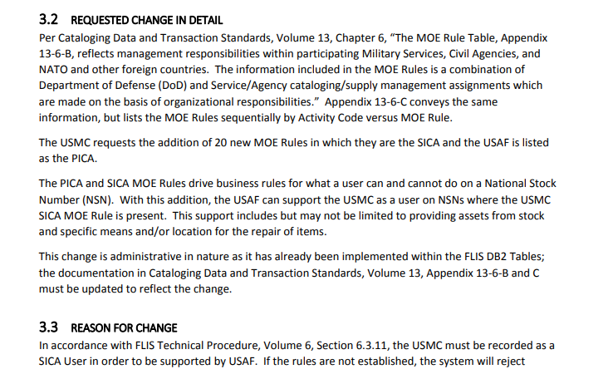
Example of Requested Change in Detail and Reason for Change for a MOE Rule Change

Information that must also appear on the CDC includes data required for CDTS Volume 13, Appendix 13-6-B such as:
- MOE Rule(s)
- MOE Code
- Status Code
- PICA and PICA LOA
- SICA and SICA LOA
- And if necessary, Submitter, Collaborator, and/or Receiver

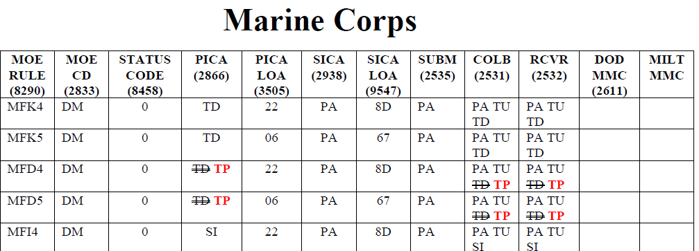
Example of MOE Rule Changes to CDTS Volume 13, Appendix 13-6-A

In some situations, the Service may also need to establish additional codes, such as Activity Codes; these codes must also be present in the CDC.

Submitting the CDC to the Service/Agency FCC Voting Representative
Upon completion of the CDC, the Service submits the Change to their FCC Voting Representative. The FCC Voting representative will review the submission, ensuring the change fully explains the requirement.
FCC Voting Members must then submit Draft CDCs to FederalCatalogCommittee@dla.mil and EBSO.CDS@dla.mil.

FCC Leadership Review
The CDC is reviewed by FCC Leadership to ensure important details are present, accurate, and not already present in FLIS. FCC Leadership will then send the CDC to EBSO, initiating work on the change.

EBSO Review and Internal Staffing
EBSO thoroughly reviews all aspects of the CDC to ensure it is accurate, fully conveys the change, and that it does not affect any other data. EBSO may add additional relevant information to the CDC if it lends credence to or better details the change. Typically, this includes:
- Explanation of codes and their function
- Citations of affected Cataloging Data Transactions and Standards (CDTS) Volumes
- FLIS DB2 Tables to be impacted by the CDC
- Any additional relevant details that assist readers in understanding the change
Should EBSO have any questions, they will coordinate with the FCC Voting Representative, including FCC Leadership on their inquiry for situational awareness.
After EBSO completes their review and all additional necessary information is documented in the CDC, Internal Staffing will begin. This process allows EBSO as well as Cataloging Subject Matter Experts, and FLIS Database Administrators to review the CDC, ensuring the change is both adequate in details and factually described.
CDC Preparation Tip:

Published ACDCs can be used as framework for new, similar requests. Find them at:
www.dla.mil/EBSO-ACDC
This is a vital quality control mechanism, ensuring only accurate data reaches FLIS.
When all parties are satisfied with the CDC and have signed off on the Internal Staffing page, the CDC is prepared for EBSO Director Signature, and sent to the FCC Mailbox as an Approved Administrative Cataloging Data Change (ACDC). EBSO also publishes the change to the web and updates the affected volume(s).

FCC Leadership Distribution
FCC Leadership will distribute the new Administrative ACDC to the FCC Member Distribution list, ensuring the community is aware of the change(s).
In the event that FCC Members require a change based on the impacts of the new ACDC, they must also submit a CDC. This will become an Addendum to the original change, citing the first CDC details as well as its resulting impact.

Scenario #1: Example ACDCs:
Below are examples of actual MOE Rule focused published ACDCs. These may provide insight during preparation of new CDCs:
- ACDC 0001, Administrative Approved Cataloging Data Change (ACDC) 0001, Addition of Unites States Marine Corps (USMC) Secondary Inventory Control Activity (SICA) Major Organizational Entity (MOE) Rule for United States Air Force (USAF) as Primary Inventory Control Activity (PICA)

- ACDC 0001A, Approved Addendum to ACDC 0001 to correct submitter information and add updated effective dates to affected Major Organizational Entity (MOE) Rules

- ACDC 0011, Approved Cataloging Data Change (ACDC) 0011, Addition of United States Marine Corps (USMC) Major Organizational Entity (MOE) Rules for United States Air Force (USAF) as Primary Inventory Control Activity (PICA)

  - ACDC 0014, Administrative Approved Cataloging Data Change (ACDC) 0014, Updates To Volumes 10 and 13 Due To India Becoming a Tier 2 Country)

