1. Purpose. The purpose of this document is to provide Defense Logistics Agency Logistics Management Standards Office (DLMSO) and DLA Transaction Services with the workflow requirements specifications for the Marine Corps’ internal process for managing its Department of Defense Activity Address Codes (DoDAACs).

a. For nearly 24 years, the Marine Corps’ internal process for managing its DoDAACs has largely been adhoc and facilitated by phone calls and e-mail traffic without proper management controls and approval authorities. The Marine Corps has since undertaken an ambitious project to correct and validate 24 years of unchecked data and re-engineer its internal workflow process to ensure proper authorities and management controls are instilled, and to ensure it is in keeping with DoD policy.

b. To guide this process, the Marine Corps’ has published an interim update in its policy for managing DoDAACs and is in the process of revising a more comprehensive standing policy that will standardize the process and enable the proper application of management controls and metrics to ensure compliance and safeguard the accuracy of the data maintained in the DoDAAD. In consonance with this policy update, an enterprise-wide validation of all Marine Corps DoDAACs is underway which will serve to clean up the data. The problem, however, is that regardless of publishing updated policy, unless some workflow enabler is implemented, maintaining the data accurate remains a challenge. It is for this reason that the Marine Corps has begun exploring the development of an information technology enabler to facilitate the workflow process requirement that will ensure the data being submitted, reviewed, and ultimately approved flows through the correct authorities and ensures accuracy before a DoDAAC is created, updated, or deleted.

2. Critical Requirements. Since the current process is largely facilitated by sending attachments via e-mail chains, there is currently no means of ensuring that the proper authorities have approved the requests other than by checking via phone calls and additional e-mails. Additionally, there is currently no effective means of tracking requests, archiving or retrieving them, ensuring that data is accurate, or that authorized individuals initiated or reviewed the data prior to forwarding. To ensure the most efficacious workflow is developed, the following critical requirements are provided:

* Ability to manage the DoDAAC life cycle to include the creation, updates, and deletion of USMC DoDAACs via a web-based management system.
* Ability for requests to be validated at time of submission against business rules to prevent invalid request from being entered.
* Ability to act as the central DoDAAC management point for the USMC.
* Ability to interface into current systems that require DoDAAC information and provide updates regarding DoDAAC changes to those systems.
* Ability to provide an audit trail for DoDAAC changes.
* Ability for requesting users to get status reports on their request.
* Ability for CSP to assign MAJCOMs for approval access in the workflow.
* Ability for MAJCOMs to have proper management ability over their respective DoDAACs.
* Ability for MAJCOMs to assign authorized users within their MAJCOM who can submit changes to DoDAACs within that MAJCOM.
* Ability for CSP to override MAJCOMs’ authorized user assignments.
* Ability of system to deactivate MAJCOM and authorized user access on a pre-determined time frame (one year access renewal).
* Ability to facilitate intra-agency cross-functional authority approvals at the headquarters (CSP) level for assignment of authority codes, procurement flag, and standardized TAC validations.
* Ability for workflow to seamlessly update DoDAAF once CSP enters final data for a DoDAAC request.
* Ability to facilitate unit rotation requests that impact more than one DoDAAC/MAJCOM.
* Ability to deny submission or forward of a request unless all critical data fields have been properly addressed.

3. Process Workflow. The core process of the workflow follows the basic process established by DLMSO: User to MAJCOM Monitor to CSP, with some additional routing at the CSP level for additional authorities (See Figure 1). The following is germane:

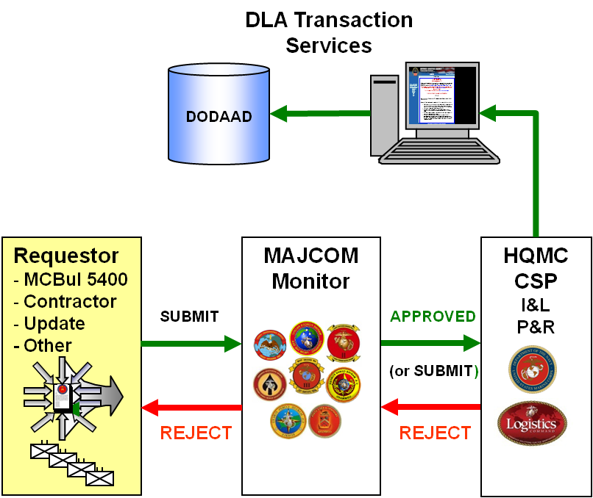

Figure 1. -- High Level Process View

4. Role-Based Workflow. There are several roles with capabilities and responsibilities necessary to any workflow. For this particular workflow, certain roles and abilities are core to every potential user (See Figure 2 below.). Beyond these core functions, each role further defines additional functions necessary to facilitate the workflow. The following are provided:

a. Anyone. Any user should be able to access the DoDAAD to query a particular DoDAAC and view its pedigree data. Any user should also be able to initiate a request for a new DoDAAC, since it is a record not already assigned to a particular MAJCOM. A request for access will be forwarded to the requestor’s MAJCOM Monitor for approval. If approved, the user is registered within the system and the requestor is notified. If rejected, the requestor is notified of rejection. Users should request access to the MAJCOM and provide information for the DoDAAC with which he is associated. A registered user can request changes to other DoDAACs within his MAJCOM (see Requestor). The user should request access for up to one year, and the MAJCOM Monitor can create an expiration of the account. Users added at the MAJCOM Monitor role need to be approved by the CSP.

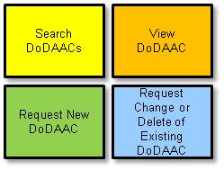

Figure 2. – Core User Functions

b. Requestor. A Requestor is any user who has been authorized by a MAJCOM Monitor to submit updates or deletions on existing DoDAACs within that MAJCOM. A Requestor can query the DoDAAD, view records, request a new DoDAAC, as well as submit updates/deletions to existing DoDAACs within the MAJCOM to which he/she belongs. A Requestor should also be able to track the status of a request and have some archive capability at his level.

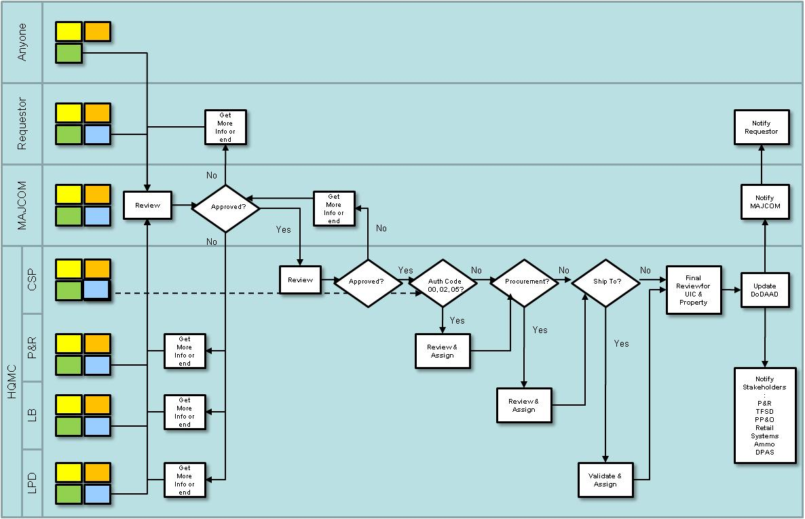

Figure 3. -- Detailed Workflow Process View

c. MAJCOM Monitor. The Major Command (MAJCOM) DoDAAC Monitor (MCM) is authorized access by the CSP to manage and approve DoDAACs within the MAJCOM for which assigned. The MCM further authorizes Requestors to have update/delete request access within that MAJCOM. The MCM is able to search, view, and request new DoDAACs like any user, but can also submit updates and deletions for DoDAACs within that MAJCOM. Additionally, the MAJCOM Monitor can approve and forward or disapprove and send back any requests generated by any users and Requestors within his/her MAJCOM. Ideally, the MCM should be able to pull DoDAACs from the DoDAAD, en masse, for his/her MAJCOM. Additionally, it would be beneficial if some management functions for the MCM were included in this workflow capability (i.e., tracking, status, archiving, etc.) as well as a system-to-system relational table (i.e., DoDAAD/SABRS/SASSY/TFSMS/MCTFS).

d. HQMC. Within HQMC, there are various routings that are necessary to comprehensively address approval requirements necessary to create, update, or delete a DoDAAC.

(1) Central Service Point (CSP)

(a) The Deputy Commandant for Installations and Logistics (DC I&L) is ultimately responsible for the Marine Corps’ portion of the DoDAAD. Within DC I&L, the Director of Logistics Plans, Policies, and Strategic Mobility Division (LP) is charged with this management function. Within LP, the Logistics Policies and Capabilities Branch publishes policy for the Marine Corps’ management of its DoDAACs, and assigns the role of CSP for the Marine Corps. Presently, LPC-2 (Supply Policy and Capabilities Section) is the primary CSP.

(b) The CSP is the ultimate recipient of all requests and is responsible for actually updating the DoDAAD. The CSP, in consonance with other stakeholders at the HQMC level, will be the final approval authority for requests and will ensure proper coordination to ensure all authorities have been made in processing a request. These authorities depend upon the nature of the DoDAAC and/or the business process(es) for which that DoDAAC is being created/updated. The CSP will also be responsible for granting access to the workflow for MCMs and should have the ability to override MCM authorizations of Requestors. The CSP should also have the ability to route requests back to either the MCM and/or the Requestor/Any User, as well as send notifications out to other stakeholders in the process as necessary (See Notifications below.). The CSP should also have the ability to archive, track, recall, and perform management functions (metrics) associated with DoDAAC requests and data.

(2) Financial Authority. The Marine Corps uses DoDAACs as financial Unit Identification Codes (UICs) within its financial management system, Standard Accounting, Budget, and Reporting System (SABRS). As such SABRS and the DoDAAD are inextricably linked.

(a) The Deputy Commandant for Programs and Resources (DC P&R) is responsible to the Commandant of the Marine Corps for developing and defending the Marine Corps financial requirements, policies, and programs. The P&R Department formulates the principles and policies that enable effective control and oversight of all Marine Corps financial operations to include budget execution, reporting on Marine Corps appropriations, and audit and review functions. DC P&R is the functional advocate for financial management systems (e.g., SABRS) and as such, provides financial management policy input to DC I&L in support of logistics policy.

(b) Accounting and Financial Systems Branch (RFA). RFA is responsible for maintaining the financial tables for the Marine Corps in SABRS. Because SABRS uses DoDAACs as its financial UICs, and because the authority codes of the DoDAACs have internal business rules attached to them in SABRS, P&R is responsible for approving authority codes 00, 02, and 05 for all DoDAACs. These DoDAACs, once created, will eventually be loaded to SABRS accordingly. As such, the workflow needs to be able to pass requests from the CSP to RFA for approval of authority codes 00, 02, and 05 before creating/updating the DoDAAC. Similarly, a notification to P&R RFA is necessary if/when a DoDAAC is created, updated, or deleted that has an authority code of 00, 02, or 05.

(3) Procurement Authority. DC I&L Contracting Division (LB) is responsible for Marine Corps Contracting. Any DoDAAC that requires Procurement Authority must be approved by I&L LB prior to creation of the DoDAAC. The workflow needs to be able to pass requests from the CSP to LB for approval of procurement authority. Similarly, whenever a DoDAAC is created, updated, or deleted that has a Procurement Flag of “Y,” the ability to send a notification to I&L LB is critical.

(4) Transportation Information. DC I&L Logistics Distribution Policy Branch (LPD) is responsible for Distribution Policy for the Marine Corps. They are also responsible for managing Transportation Account Codes for military shipments within the Marine Corps. To facilitate this, LPD is standardizing TAC2 addresses for units and activities that are supported by a DMO/TMO. Any DoDAACs that are authorized ship-to must be vetted through I&L LPD to ensure the proper consolidated and standardized TAC2 is being used. If the unit is not supported by a DMO/TMO, the TAC4 shall be used with the unit’s parcel or building address for shipments. The workflow needs to be able to facilitate this communication between the CSP and LPD. Accordingly, it is necessary that notifications be made to I&L LPD upon creation, change, or deletion to any DoDAAC with standardized TAC2.

(5) Additional Notifications. Once a DoDAAC is created, depending on the nature of the DoDAAC, other notifications need to be possible to alert other enterprise-level system owners of the changes made.

(a) Retail Systems Branch, MarCorLogCom. The Retail Systems Branch is responsible for managing all of the Retail Supply Systems within the Marine Corps. Since these systems are the principal users of DoDAACs, it is critical that a notification mechanism be possible to identify DoDAAC changes for DoDAACs that have military property and/or requisitioning associated with them, so that those systems can be both checked and updated as well.

(b) Total Force Structure Division (TFSD). The Deputy Commandant for Combat Development and Integration (DC CD&I) is responsible for maintaining the Marine Corps’ UICs. TFSD executes this management function for DC CD&I. Because UICs and DoDAACs in the Marine Corps are not the same, maintaining a relationship between these identifiers is critical. The workflow needs to be able to facilitate the exchange between the CSP and TFSD to adjudicate possible conflicts of identifiers already being used (UICs or DoDAACs) to ensure, to the greatest extent possible, that DoDAACs and UICs for a unit match. As such, any time a DoDAAC is created, updated, or deleted, a notification to TFSD of the change needs to be possible so that the UIC system (TFSMS) can be updated accordingly.

(c) Program Manager, Ammunition. The system and process for managing Ammunition in the Marine Corps relies on DoDAAC info. Any time a DoDAAC is changed that impacts a Retail Ammunition unit/activity, a notification to PM Ammo needs to be possible.

(d) Overseas Contingency Operations (OCO). When DoDAACs are created for task-organized units in support of OCO, the planning, management, and execution of this process is labor intensive and involves multiple stakeholders to the global sourcing of equipment and resources in support of the operation. The Marine Corps currently manages and executes the management of these operations outside several of its enterprise systems, but still uses DoDAACs. To properly establish a DoDAAC for an OCO requires the careful coordination between several offices within HQMC and the ability to make relationships between several additional databases. The workflow needs to be able to accommodate the notifications necessary to facilitate this complex process.

(6) Once a DoDAAC Request has been processed, a notification of the completed request back to the MAJCOM and Requestor must be possible as well.

4. Transactional Processes. The Marine Corps currently uses a NAVMC Form 11718 USMC DoDAAC Request to facilitate capturing and conveying all the pedigree information necessary to create a DoDAAC or RIC. This form encompasses all 96 currently used data fields of the DoDAAC. Presently, it is attached to e-mails and routed accordingly; however, this workflow should replace this NAVMC and ensure that all data fields are integrated into the workflow.

a. Requests for New DODAAC. Any user can request a new DODAAC from the system; however, requests for new DoDAACs depend on whether the DoDAAC is required for an existing unit to enable a business process, for a task-organized unit for an exercise or operation, or if the DoDAAC is for a new unit. Whatever the case, once the Request is accurately and completely completed, it should be routed to the MCM for review and approval.

(1) Existing Unit. If the new DoDAAC is for an existing unit, the request needs to identify the appropriate MAJCOM that the DoDAAC will fall under. Ideally, this type of request would be generated at the MCM level.

(2) Task-organized Unit. In this case, the requestor would also ideally be at the MCM level. This particular type of DoDAAC has special assignment logic attached to it at the CSP level that the MCM needs to be aware of. This type of request also has to be potentially coordinated with the other impacted MAJCOM of the theater of operations into which the task-organized unit will deploy. It thus requires approval by potentially two or three MCMs.

(3) New Unit. If the request is for creating a DoDAAC for a newly activated unit, the request should be able to facilitate attaching the source document (in this case, the MCBul 5400) that officially activates the unit/activity.

b. Request for Update. Whomever initiates the update (Requestor or MCM) the request follows the same workflow as with a new DoDAAC request. If/when it is approved by the CSP, notifications should be generated back through the workflow to the initiator accordingly.

c. Request for Deletion. Deletions can be initiated by a Requestor, MCM, or the CSP.

d. Approval Process

(1) The Request. A User or Requestor logs into the system. User/Requestor fills in proper fields into web form to request a new DoDAAC. User submits form. The form will be validated to notify the user of any errors (missing required fields, invalid data). If the form does not pass validation, the user will not be able to submit it without correcting the errors. Once submission is successful, the user/requestor receives confirmation. The validation rules will be data dependent (e.g., which TACs are required changes depending on the authority code).

(2) MCM. The MCM reviews the entry and marks the request as approved or rejected. If the request is approved, it is sent to the next level of review (CSP). Initiator receives a confirmation of the MCM approval.

(3) CSP. Depending on the authority code, the request will need to be reviewed and approved by either LPD, LB, or P&R RFA before being sent to the CSP. For all other authority codes, the HQMC CSP approves the request. If the request is approved, the CSP sends that request to the DLA server for inclusion in the DoDAAD. The requestor and MCM are notified that the DoDAAC has been created. If there are other systems or users that need to be updated when a DoDAAC is created, notifications will be sent to them.

(4) At any point in the review process, the reviewer can request additional information and send it back to the requestor with comments.

e. Requests for Contractor DoDAACs. The process for requesting, updating, or deleting DoDAACs for contractors is similar to the process for military DoDAACs; however, certain additional management controls are included to address equities related to Government Furnished Property, Contractor Acquired Materiel, and restrictions on contractors imposed by the Defense Supplement to the Federal Acquisition Regulations (DFARS) (i.e., Receipt/Acceptance, etc.).

(1) Contractor. A Contractor acts as a requestor in this process to request a DoDAAC or a change/deletion to an existing DoDAAC. The contractor submits the request to the Contract Admin Office (CAO) of the Sponsor.

(2) Sponsor CAO. A CAO can also initiate a request or change/deletion of an existing DoDAAC. If the contractor is the requestor, once the CAO receives the request, the CAO will ensure that the proper language is included in the contract that stipulates the reason for which the contractor requires a DoDAAC, to include the necessary authority code. The CAO will then provide their contact information as the POC for the DoDAAC and forward to the MAJCOM for approval. If any additional information is required by the contractor, the CAO can reject the request and send it back accordingly.

(3) Management Control Activity (MCA). Within the Marine Corps, the MCA is responsible for maintaining visibility on Government Furnished Property (GFP) and monitoring Contractor Acquired Materiel (CAM). As such, the MCA acts as the MAJCOM for all contractor DoDAACs in the Marine Corps. Once a request is received by the MCA from the CAO, the MCA will review the contract to safeguard any GFP/CAM equities and ensure proper records are established accordingly to accommodate these processes. The MCA will also validate the authority code requested by the contractor/CAO for this DoDAAC with the specifics of the contract. The MCA can also reject the request if it requires further information and send it back to the CAO. If approved, however, the request is forwarded to the CSP for review.

(4) HQMC. HQMC agencies will review the request as necessary to ensure the proper authority codes are assigned and that billing information is in accord with the contract. In some cases, the contract will be scrutinized to ensure it has been properly established to facilitate the intended purpose/process. Once all the information has been validated, the CSP will create the DoDAAC and send notifications out as necessary. See Figure 4.

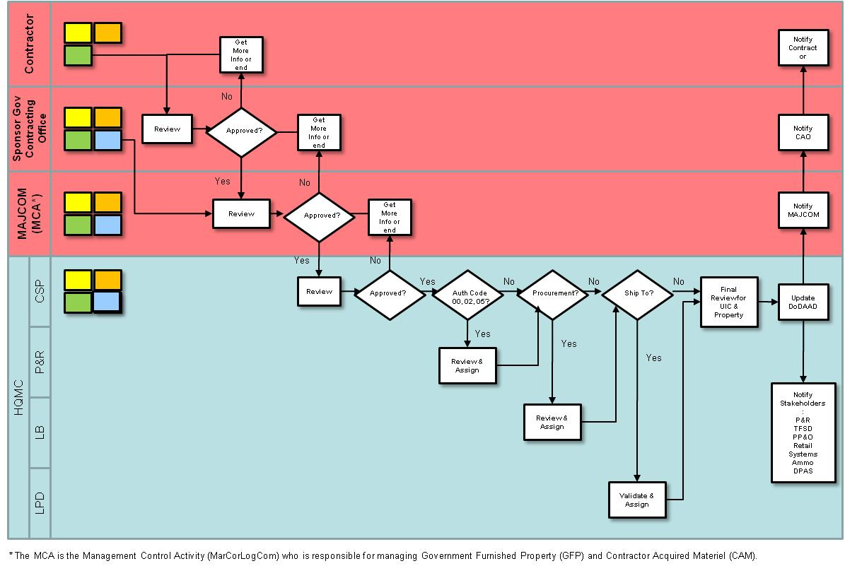

Figure 4. -- Detailed Workflow Process View for Contractor DoDAACs

5. Auditing. The entire process for creating, updating, and deleting a DoDAAC request should have associated audit trails. This will allow the administrators/CSP to closely monitor the request’s process and respond to any misuse of the system. All users that interact with a request will have their credentials tied to that request, and that information will remain in the system after the request has been processed.

6. Users and Roles. The system will use role-based permissioning scheme to control access to functionality. The main website will be accessible by anonymous users.

a. Anonymous users will be able to search and view DoDAAC information and

request access to the system in order to request changes or additions to DoDAACs. A request for access will be forwarded to the requestor’s MCM for approval. If approved, the user is registered within the system and the requestor is notified. If rejected, the requestor is notified of rejection. Users should request access to the MAJCOM and provide information for the DoDAAC(s) with which he is associated. A registered user can request changes to other DoDAACs within his MAJCOM. The user should request access for up to one year, and the MCM can create an expiration of the account. Users added at the MCM level need to be approved by the HQMC CSP user or DLA Transaction Services.

b. Additional functionality will be available to authenticated users. These users may be assigned to the following roles:

(1) Requestor. This role will be able to submit add/change/delete DODAAC requests. He will also be able to check on the status of his requests.

(2) MCM. This role will be responsible for reviewing add/change requests for DoDAACs that belong within their MAJCOM. The add/change requests will specify the MAJCOM for the request, and the request will be routed to the MCM for that MAJCOM.

(3) CSP. This role will be allowed to view/approve requests that have been approved and forwarded to them by the MCM users. The CSP will be able to approve the requests or to forward to other HQMC stakeholders for further review. The CSP also has the authority to make approved changes to the DLA DoDAAD database.

(4) HQMC. These roles will be responsible for reviewing requests that have been forwarded to them by the CSP. For certain requests (e.g. specific authority codes), the HQMC role will be responsible for reviewing the request after approval by the MCM and prior to final review by the CSP.

(5) System Administrator. This role will be able to add/delete users, inactivate/reactivate users, and reset passwords.