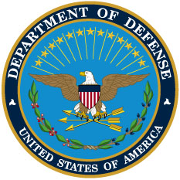

DAAS
DEFENSE
AUTOMATIC
ADDRESSING
SYSTEM

June 5, 2012
DEPUTY ASSISTANT SECRETARY OF DEFENSE
(SUPPLY CHAIN INTEGRATION)

