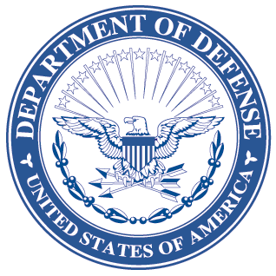OFFICE OF THE ASSISTANT SECRETARY OF DEFENSE

3000 DEFENSE PENTAGON

WASHINGTON, DC 20301-3000

LOGISTICS AND

MATERIEL READINESS

DLM 4000.25-4, April 29, 2016

Change 2

DEFENSE AUTOMATIC ADDRESSING SYSTEM

CHANGE 2

I. This change to DLM 4000.25-4, Defense Automatic Addressing System (DAAS), June 2012, is published by direction of the Deputy Assistant Secretary of Defense for Supply Chain Integration under the authority of DoD Instruction (DoDI) 4140.01, “DoD Supply Chain Materiel Management Policy,” December 14, 2011. Unless otherwise noted, revised text in the manual is identified by ***bold, italicized*** print. The exception would be when the entire chapter or appendix is replaced, or a new one added. Change 2 also includes administrative updates: The title of DoDM 4140.1-R is updated to DoDM 4140.01. In accordance with new direction for issuances, “shall” has been replaced by “will”, “must”, or other appropriate words or phrases throughout the updated documents. In accordance with DLA General Order No. 07-15 (09/14/2015), references to “DLA Transaction Services” are changed to “Transaction Services”, and “DLA Logistics Information Services” to “Logistics Information Services.

II. This change includes Approved Defense Logistics Management Standards (DLMS) Changes (ADC) published by Defense Logistics Management Standards Office memorandum:

1. ADC 1177 dated December 8, 2015. Documents the interim state routing solution that has been developed and tested by the Defense Security Assistance Development Center (DSADC) for the SCES Program, working in cooperation with Naval Supply Systems Command, Weapon System Support (NAVSUP WSS), DLMSO, and Transaction Services.
2. ADC 1178 dated August 5, 2015, Revises DoDAAD Bureau Codes (DoDAAD); no changes to DLM manuals.

III. The list below identifies the chapters, appendices, or other files from the manual that are updated by this change:

| **Added or Replaced Files** |
| --- |
| Change History Page |
| Appendix 2 |
|  |

IV. This change is incorporated into the on-line Defense Logistics Management Standards manual at the Defense Logistics Managements Standards Office Website   
[www.dlmso.dla.mil/elibrary/manuals/dlm/dlm_pubs.asp](http://www.dlmso.dla.mil/elibrary/manuals/dlm/dlm_pubs.asp), and the PDF file containing the entire set of change files is available at  
[www.dlmso.dla.mil/eLibrary/Manuals/DLMS/formal_changes.asp](http://www.dlmso.dla.mil/eLibrary/Manuals/DLMS/formal_changes.asp).

