C9. CHAPTER 9
LOGISTICS DATA RESOURCE MANAGEMENT SYSTEM
C9.1. PURPOSE. This chapter provides basic information about DLMS data dictionaries and simple navigation in the Logistics Data Resource Management System (LOGDRMS). The data maintenance process is described in C5.3 and C5.4.
C9.2. LOGDRMS. LOGDRMS is the online repository of Defense Logistics Management Standards (DLMS) data elements, definitions, qualifiers, and the DLMS Supplement (hereafter referred to as DLMS Implementation Convention (IC)) transaction structures.
C9.3. ACCESS. The LOGDRMS website is publically accessible from the Defense Logistics Management Standards Office Website. There is no logon or common access card (CAC) requirement to see data on LOGDRMS. Only unclassified, publicly releasable content is to be provided on LOGDRMS. The link to the LOGDRMS home page is www.dlmso.dla.mil/eApplications/LogDataAdmin/dlmsdicdir.asp.
C9.4. HOMEPAGE. The LODGRMS homepage contains overview information and links to the suite of directories in LOGDRMS. LOGDRMS contains three views with sub directories. Figure C9.F1 shows the expanded definition for the three views identified below.
- DLMS Data Element Dictionary/Directory (DEDD)
- Dictionary/Directory of DLMS Qualifiers (Reference Tables)
ANSI X12 Repository Figure C9.F1. LOGDRMS Home Page
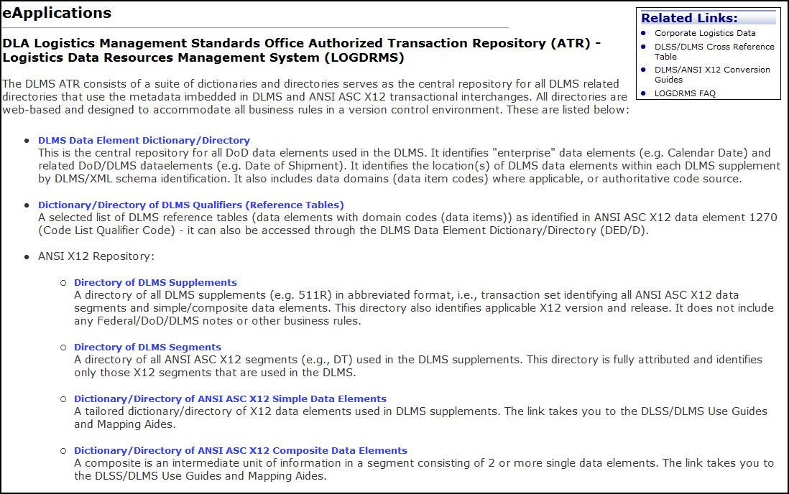
C9.4.1. DLMS Data Element Dictionary/Directory. The DEDD is the central directory for all DoD logistics data elements used in the DLMS. Entries are made for core, domain, and DLMS data element definitions. Select one of the three elements shown below from the drop down list and click the search button next to the element to show the details of the element (Figure C9.F2).
- Core Elements
- Domain Codes and Qualifier Element
- DLMS Element
Core Elements, Domain/Qualifiers, and DLMS Elements are discussed in more detail in the following subsections.
Figure C9.F2. DLMS Data Element Dictionary
https://www.dlmso.dla.mil/LOGDRMS/DLMSQualifier

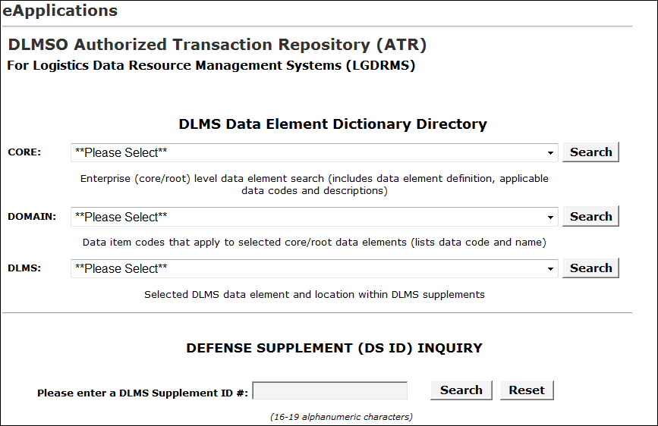
C9.4.1.1. Core Elements
C9.4.1.1.1. This section describes the results of selecting a Core data element from Figure C9.F2. A Core data element is a logical concept that is the foundation for one or more DLMS elements. The Core data element page (Figure C9.F3) will display the applicable Core data element, related DLMS data elements, and applicable domain data (data codes). It will also show associated DLMS IC, numbers with identified location(s) within each IC.
C9.4.1.1.2. For example, the Core data element “DoDAAC (Department of Defense Activity Address Code)” (Figure C9.F3.), displays the core definition that underlies the use of DoDAAC with the DLMS and the associated DLMS data elements (e.g. DoDAAC - BILL AND SHIP TO PARTY, DoDAAC - BILL TO PARTY (FOR DISPOSAL OF HAZARDOUS MATERIEL)).
C9.4.1.1.3. Clicking on the “Logistics Qualifier Link” (Figure C9.F3.) will display the page for a linked qualifier, if there is a qualifier reference table for the element.
Figure C9.F3. DLMS Core Element Example
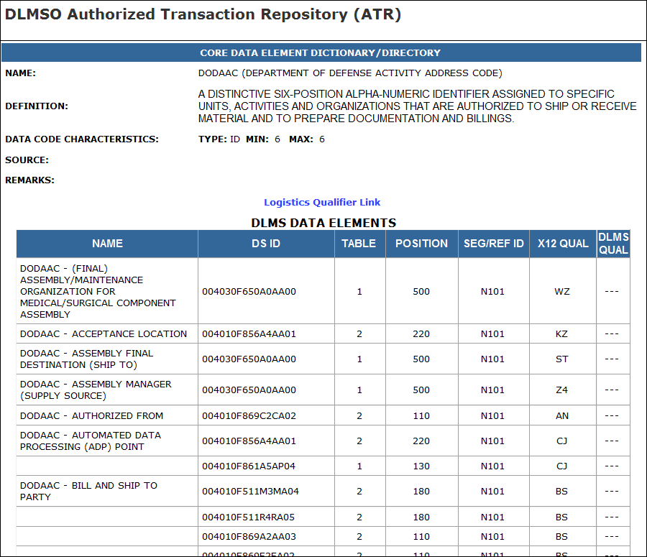
C9.4.1.2. Domain Codes. This section describes the results of selecting a Domain from Figure C9.F2. Domain codes are DoD codes mapped to codes of an ASC X12 standard element. The X12 code may or may not match the DoD code, but should be as close as possible. For example, Unit of Measure (UoM) (core data element) contains set of measurement values: Cubic Foot, GA-Gallon. “Type of Unit Price Code” has codes associated with the Core data element, (Figure C9.F4.). Even though every Core Element is in the Domain drop down list, not every Core data element has Domain codes. The Domain result page may also link to a DLMS qualifier list.
Figure C9.F4. Domain Example
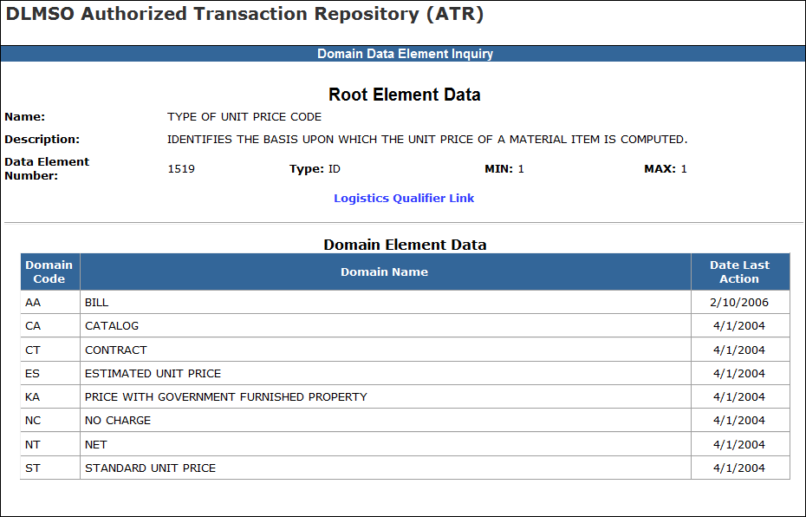

C9.4.1.3. DLMS Data Elements. This section describes the results of selecting a DLMS Element from Figure C9.F2. above. DLMS elements are the functional data standards for the logistics community and are the basis for identifying transaction data requirements. For example, the core data element, “Department of Defense Activity Address Code (DoDAAC)”, is the parent and includes DLMS data variations like “DoDAAC – Bill To Party” and “DoDAAC – Delivery Address”. The results of the DLMS inquiry will display a list of DLMS ICs in which the DLMS data element are used (Figure C9.F5.).
Figure C9.F5. DLMS Data Elements
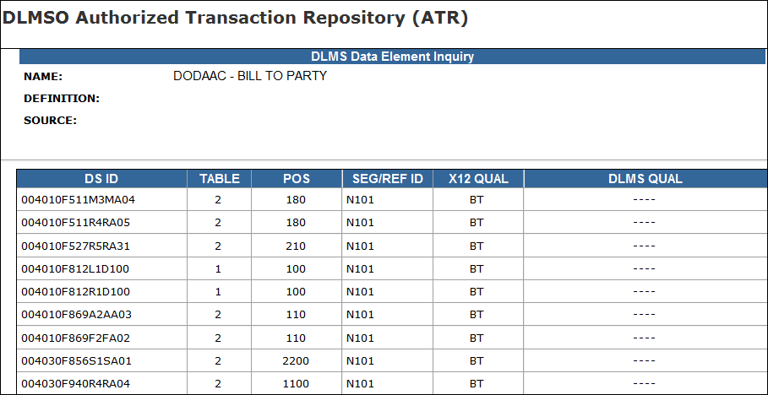

C9.4.1.4. DLMS Implementation Convention Inquiry. This section describes the results of searching a DLMS IC from Figure C9.F2. above. The resulting DLMS IC will display all associated DLMS data elements, X12 qualifiers, and locations in a particular IC. The example in Figure C9.F6. shows the results for DLMS IC“004010F511R4RA05”.
Figure C9.F6. DLMS Implementation Convention Inquiry
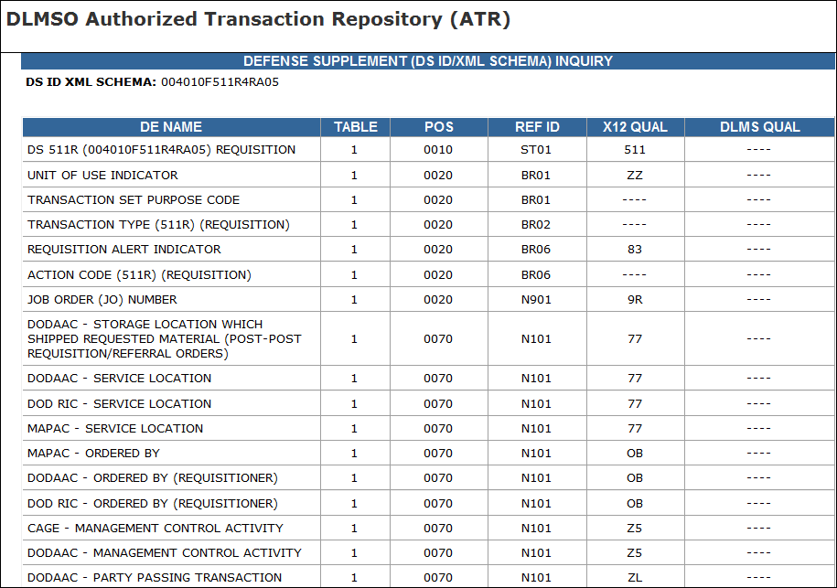

C9.4.2. DLMS Qualifiers. In Figure C9.F7., the DLMS Qualifiers page provides a way to browse or search for the DLMS managed code lists used in the DLMS IC. The DLMS Qualifiers represent a combination of DoD logistics functional data elements for which the authoritative source is DLM 4000.25, Defense Logistics Management System manual.
Figure C9.F7. DLMS Qualifiers
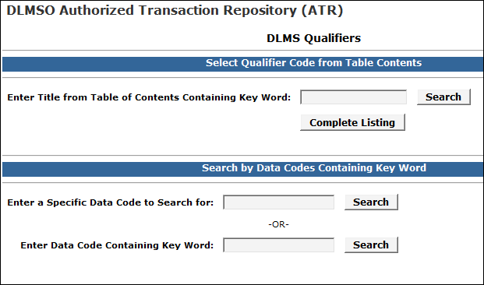
C9.4.2.1 Users may enter specific keyword searches to retrieve the desire Qualifier lists, however the best way to view the information is to click on the “Complete Listing” tab for a comprehensive view of all Qualifiers, as shown in Figure C9.F8.
Figure C9.F8. Complete DLMS Qualifiers
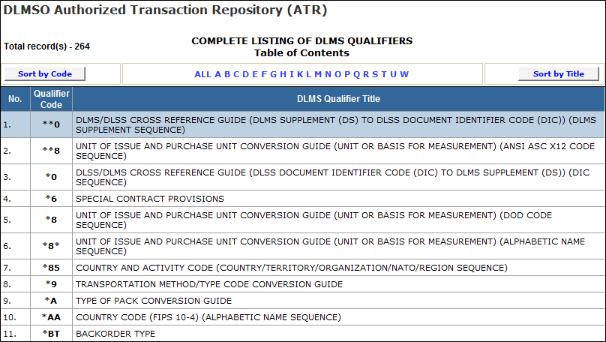
C9.4.2.2. External qualifiers are DoD codes recognized within the X12 Standard as being managed by an external source. For most qualifiers in DLMS, the Defense Logistics Management Standards Office is the recognized code source. The DLMS also use qualifier codes from other sources such as U.S. Transportation Command (USTRANSCOM) for certain transportation related code lists. A qualifier code value will always be the code transacted. Most of the DLMS qualifiers are registered under ASC X12 Data Element 1270 (Code List Qualifier Code) and are used in Data Segment LQ identifying the coded entry to its qualifier. The presence of an asterisk (*) in the qualifier code indicates one of the following conditions:
- The entry represents a conversion guide required or used in the legacy 80 record position Defense Logistics Standard Systems (DLSS)/DLMS translation process
www.dlmso.dla.mil/eApplications/LogDataAdmin/dlmsansiconverguides.asp.
- The entry shows a secondary sequence of a data code within a qualifier (alphabetic/alphanumeric code sequence or clear-text name),
- The entry is a guide for cross-reference of DoD Document Identifier Codes (DIC) to DLMS ICs.
- The entry identifies a DoD managed code list (qualifier not in the X12 DE1270 code list).
C9.4.2.3. Service and Agency Code Example. Selecting “Service and Agency Code” from Figure C9.F8. above will display a list of valid codes and associated agency names and usage criteria. For example, B – US Army, FMS AND GRANT AID USE ONLY and C – US Army, CONTRACTOR USE ONLY. The results of the inquiry are displayed as shown in Figure C9.F9.
Figure C9.F9. DLMS Qualifier 71
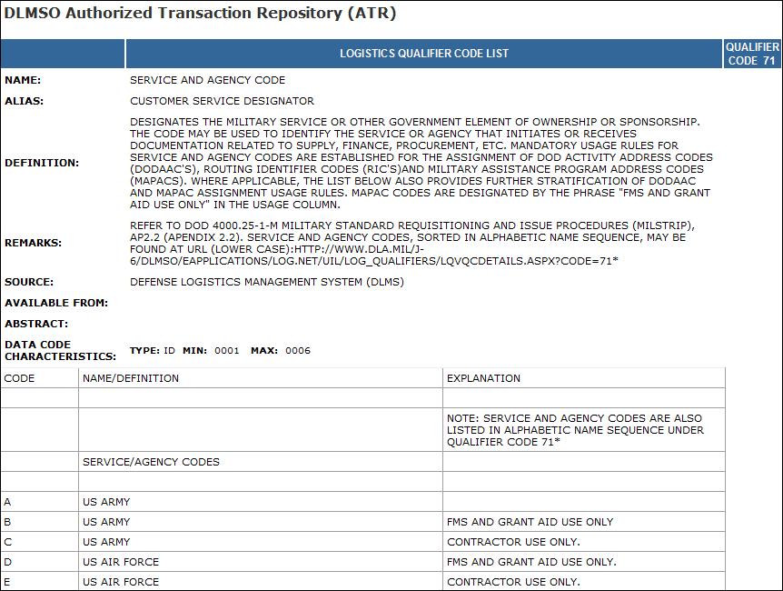
C9.4.3. ANSI X12 Repository. The ANSI X12 Repository reflects the ANSI X12 structures of the DLMS ICs, leaving out the notes. The side navigation bar for LOGDRMS has links to the DLMS IC, segments, composite data elements, simple data elements views. The structures are hyperlinked to enable browsing up or down the parent/child relationships of the structures. The details of X12 concepts are described in Chapter 6.
C9.4.3.1. Directory of DLMS Implementation Conventions. A directory of all DLMS ICs in abbreviated format, i.e., transaction set identifying all American National Standards Institute (ANSI) Accredited Standards Committee (ASC) X12 data segments and simple/composite data elements. This directory also identifies applicable X12 version and release (Figure C9.F10.). NOTE: The authoritative source for the DLMS IC is located on the DLMS IC page.
Figure C9.F10. DLMS Implementation Conventions
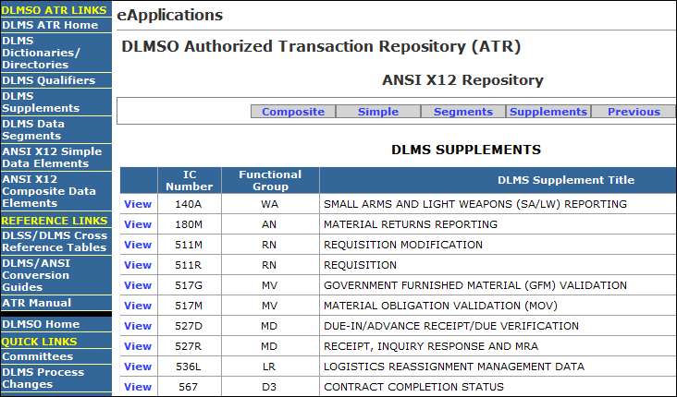
C9.4.3.2. Once a user clicks on “View” link in Figure C9.F10. (e.g., 511R), the DLMS IC Transaction Set Specifications will be displayed (Figure C9.F11.).
Figure C9.F11. Implementation Convention Transaction Set Specifications
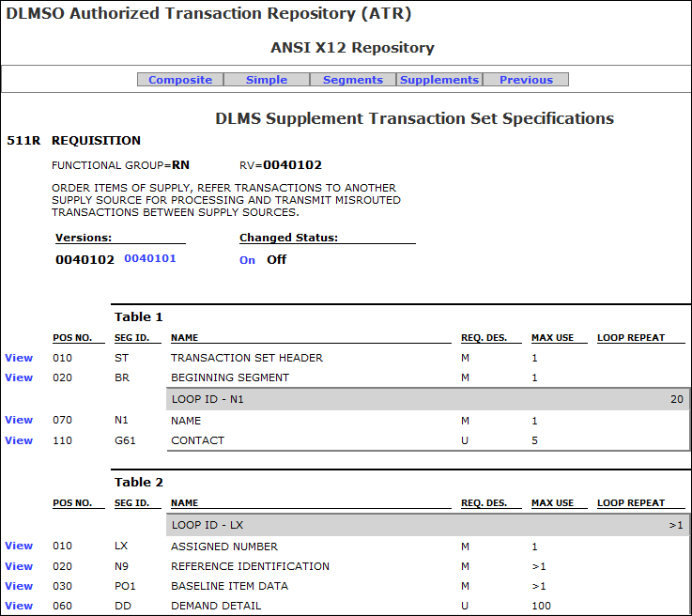
C9.4.3.3. Directory of DLMS Segments. This directory identifies only those X12 segments that are used in the DLMS ICs (Figure C9.F12.).
Figure C9.F12. Segments
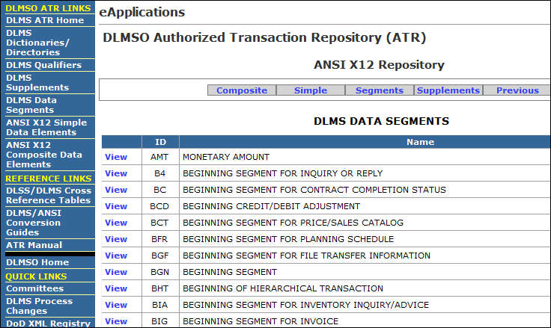
C9.4.3.4. Once a user clicks on “View” link in Figure C9.F12, (e.g., “Beginning Segment”), the Segment Specifications will display (Figure C9.F13.).
Figure C9.F13. Segment Specifications
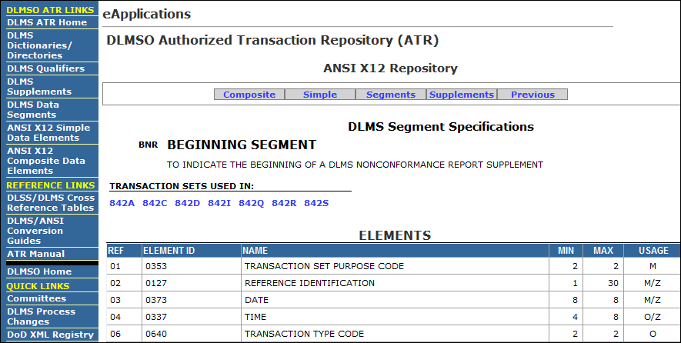
C9.4.3.5. Directory of ANSI ASC X12 Simple Data Elements. Figure C9.F14. shows X12 data elements used in DLMS ICs.
Figure C9.F14. X12 Simple Data Elements
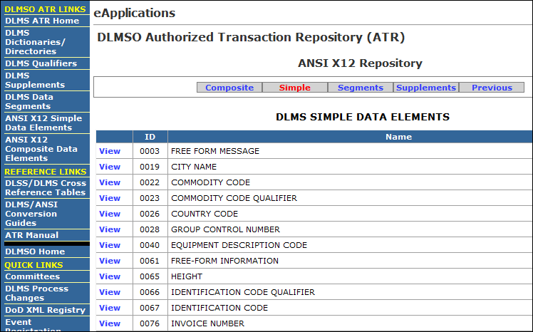
C9.4.3.6. Once a user clicks on “View” link in Figure C9.F14., (e.g., “Commodity Code Qualifier”), the DLMS Simple Data Element Specifications will be displayed (Figure C9.F15.).
Figure C9.F15. X12 Simple Data Element Specifications
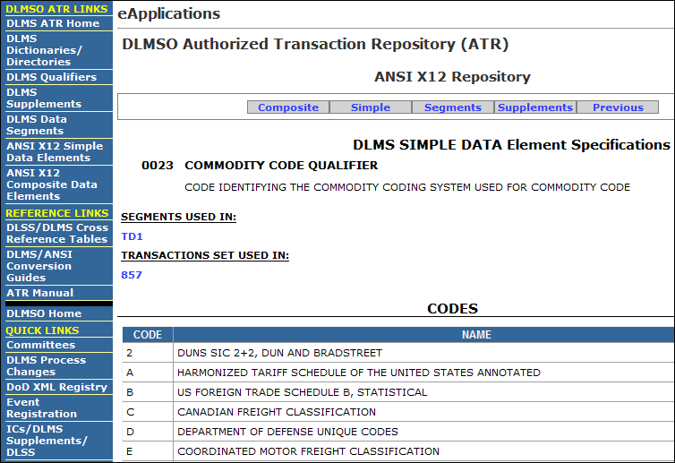
C9.4.3.7. Directory of ANSI ASC X12 Composite Data Elements. Figure C9.F16. lists the Composite Data Elements, which are intermediate units of information in a segment consisting of two or more simple data elements.
Figure C9.F16. X12 Composite Data Elements
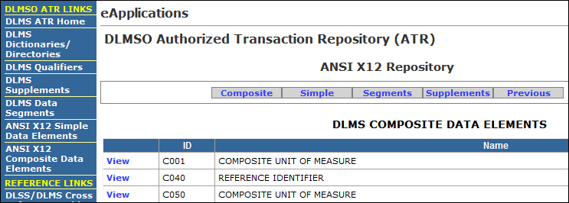
C9.4.3.8. Once a user clicks on “View” link in Figure C9.F16., (e.g., “Composite Unit of Measure”), the DLMS Composite Data Element Specifications will be displayed (Figure C9.F17.).
Figure C9.F17. Composite Data Element Specifications
