C19. CHAPTER 19

WEAPON SYSTEMS DATA CHANGE

(DLMS 888W)

C19.1. GENERAL
C19.1.1. Purpose. This chapter provides an overview for the Defense Logistics Agency (DLA) Weapon System Support Program (WSSP) data exchanges based on Volume 2 of DoDM 4140.01 requirements. Specific procedures and code lists for WSSP are found in DLAI 4140.38.
C19.1.2. Transaction. Execute WSSP data exchange functions using the Defense Logistics Management Standards (DLMS) 888W transaction. See the Defense Enterprise Data Standards Office (DEDSO) website for available formats on the DLMS implementation convention page.
C19.1.2.1. The DLMS 888W replaced both legacy WS1 and WS3 Weapon Item Data transactions in July 2005. Legacy format submissions will be honored until an unspecified future date.
C19.1.2.2. A Weapon System Designator Code (WSDC) master record must be requested and established with DLA prior to use.

C19.2. TRANSACTION FLOW
C19.2.1. The DLMS 888W, Weapon Systems Data Change (legacy WS1) transaction (2/BGN07/0150 (BGN07=W1)) flows from the participating Service/Agency weapons system program manager to the DLA inventory control point (ICP). The 888W (legacy WS1) is used to establish a stock number as having a weapon system application. The weapon system is identified by Service/Agency and the DLA assigned WSDC. Follow-on DLMS 888W (legacy WS1) transactions may be submitted to modify (overlay) or delete the initial entry.
C19.2.2. The DLMS 888W, Weapon Systems Data Change (legacy WS3) response transaction (2/BGN08/0150 (BGN08=RS)) flows from DLA ICP back to the submitting Service/Agency reflecting processing status.
C19.2.3. Transaction Map:
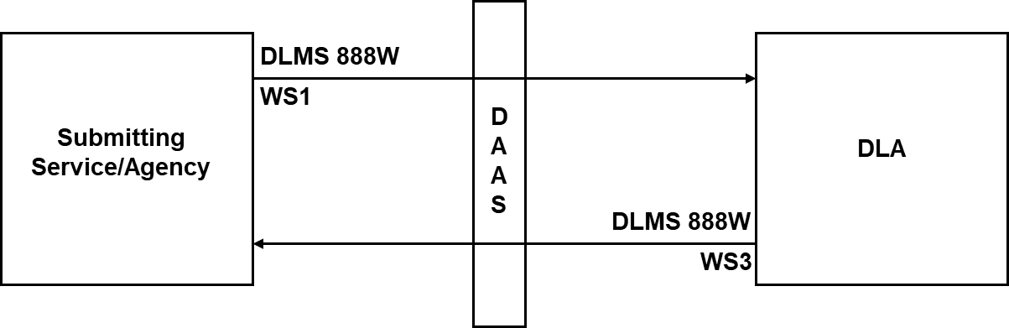
C19.3. PROCEDURES AND CODE LISTS. Code lists for WSSP are found in DLAI 4140.38. Additional support for specific codes follows:
C19.3.1. WSDC. A three-position code assigned by DLA to all weapon systems nominated by a Service/Agency for inclusion into WSSP. 2/N901/1510 (N901=W2).
C19.3.1.1. The first two positions of the WSDC will be alpha, numeric, or a combination. The third position will always be an alpha indicating the lead Service/Agency registering the weapon system in WSSP.
C19.3.1.2. The DLMS 888W has a minimum three-position/ maximum four-position code enhancement to allow for many new code assignments in the future. Service/Agencies should apply the expanded field size during implementation. Existing WSDC assignments will continue to be accepted.
C19.3.2. The following codes are found at 2/LQ01/1900:
C19.3.2.1. Weapon System Advice Code (WSAC). This two-position code is used in the initiating a DLMS 888W. (LQ01=80).
C19.3.2.2. Weapon System Status Code (WSSC). This code is used to signal what action DLA will take place on a submitted DLMS 888W transaction via a DLMS 888W response transaction. (LQ01=81).
C19.3.2.3. Weapon System Essentiality Code (WSEC). A code assigned to each stock number registered in the WSSP to indicate the degree to which the failure of the part affects the ability of the weapon system to perform its intended mission. (LQ01=FF).
C19.3.2.4. Weapon System Maintenance Code (WSMC). Used to indicate the degree to which repairability/maintenance for the specific stock number impacts an end item/weapon system performance. This is a DLA unique data element meaningful to DLA only. (LQ01=FG).

