**AP6.27. APPENDIX 6.27**

**ISSUE RELEASE/RECEIPT DOCUMENT (IRRD)  
PREPRINTED FORM WITHOUT LOGMARS BAR CODING DATA[1]**

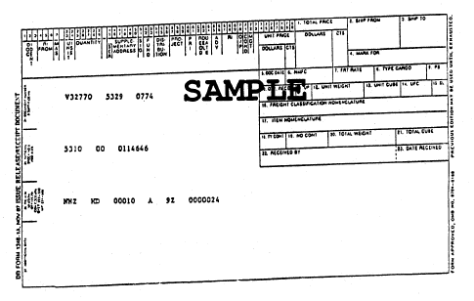

1. Unit prices obtained via electronic interfaces which are not constrained by the MILSTRIP field size will reflect the unit price as 9 digits for dollars and 2 digits for cents. If total price exceeds available space for display on the printed form, the generating application may leave blank. Refer to ADC 221, DLMS enhancement for communication of unit price and total price.