**AP6.29. APPENDIX 6.29**

**ISSUE RELEASE/RECEIPT DOCUMENT  
LASER PRINTED FORM WITH LOGMARS BAR CODING FOREIGN MILITARY SALES[1]**

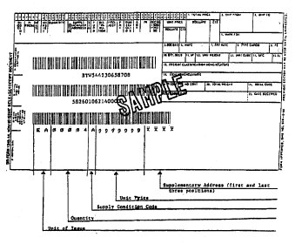

1. Unit prices obtained via electronic interfaces which are not constrained by the MILSTRIP field size will reflect the unit price as 9 digits for dollars and 2 digits for cents. If total price exceeds available space for display on the printed form, the generating application may leave blank. Refer to ADC 221.