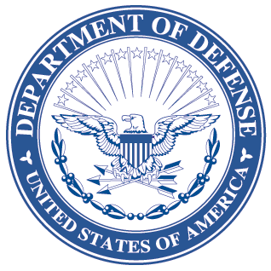
OFFICE OF THE ASSISTANT SECRETARY OF DEFENSE
3000 DEFENSE PENTAGON
WASHINGTON, DC 20301-3000

LOGISTICS AND
MATERIEL READINESS
DLM 4000.25, Volume 4, April 29, 2016
Change 6
DEFENSE LOGISTICS MANAGEMENT SYSTEM
VOLUME 4, Military Standard Billing System - Finance
CHANGE 6

I. This change to DLM 4000.25, Defense Logistics Management System (DLMS),
Volume 4, June 2012, is published by direction of the Deputy Assistant Secretary of Defense for Supply Chain Integration under the authority of DoD Instruction (DoDI) 4140.01, “DoD Supply Chain Materiel Management Policy,” December 14, 2011. Unless otherwise noted, revised text in the manual is identified by bold, italicized print. The exception would be when the entire chapter or appendix is replaced, or a new one added. Change 6 also includes administrative updates: In all updated documents "Defense Logistics Management System” is changed to "Defense Logistics Management Standards" per DoDI 8190.01E. In accordance with new direction for issuances, “shall” has been replaced by “will”, “must”, or other appropriate words or phrases throughout the updated documents. Additional administrative updates include changing “DoDM 4140.1-R” to “DoDM 4140.01”, and “DLA Logistics Management Standards” to “Defense Logistics Management Standards”.
In accordance with DLA General Order No. 07-15 (09/14/2015), references to “DLA Transaction Services” are changed to “Transaction Services”.
II. This change includes Approved Defense Logistics Management Standards (DLMS) Change (ADC) published by Defense Logistics Management Standards Office memorandum:
- ADC 1043E dated October 5, 2015. Extends Defense Automatic Addressing System (DAAS) edits for invalid or missing fund codes to include transactions with Signal Codes A, B, J, and K and one scenario pertaining to Signal Codes C and L that had previously been omitted. Revises DLMS Chapter 5, Chapter 6, and Appendix 2.2.
- ADC 1084 dated November 25, 2015. Allows credit to be issued for non-manager owned suspended stock stored at a DLA Distribution location when a stock screening request results in identification of non-compliant materiel. This change leverages existing procedures for processing of the Stock Screening Request, Storage Quality Control Report (SQCR), SDR, and Materiel Release Order (MRO) to accomplish the necessary steps to recognize, suspend, provide notification of suspected non-conforming materiel, provide credit to the materiel owner if the materiel is determined to be non-compliant, and transfer ownership to the manager—all with minimal system impact to existing systems and procedures. Revises DLMS Chapter 4, and Appendices 2.3 and 2.5 and DLMS ICs 842S/Q and 842S/R.
III. The list below identifies the chapters, appendices, or other files from the manual that are updated by this change:
Added or Replaced Files
Change History Page
Table of Contents
Chapter 4
Volume 6, Appendix 1.1
Chapter 5

Chapter 6

Appendix 2.02
Appendix 2.03
Appendix 2.05
IV. This change is incorporated into the on-line DLMS manual at the Defense Logistics Managements Standards Website Publications Page and the PDF file containing the entire set of change files is available on the Formal Changes Page.

