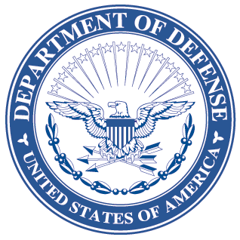
OFFICE OF THE ASSISTANT SECRETARY OF DEFENSE
3000 DEFENSE PENTAGON
WASHINGTON, DC 20301-3000
LOGISTICS AND
MATERIEL READINESS
DLM 4000.25, Volume 4, June 25, 2013
Change 2
DEFENSE LOGISTICS MANAGEMENT SYSTEM
VOLUME 4, MILITARY STANDARD BILLING SYSTEM (MILSBILLS) - FINANCE
CHANGE 2

I. This change to DLM 4000.25, Defense Logistics Management System (DLMS), Volume 4, June 2012, is published by direction of the Deputy Assistant Secretary of Defense for Supply Chain Integration under the authority of DoD Instruction (DoDI) 4140.01, “DoD Supply Chain Materiel Management Policy,” December 14, 2011. Change 2 to Volume 4 consists of administrative corrections for typos. These administrative changes are not marked in the manuals.
II. This change is incorporated into the on-line DLMS manual at the Defense Logistics Managements Standards Website Publications Page and the PDF file containing the entire set of change files is available on the Formal Changes Page.

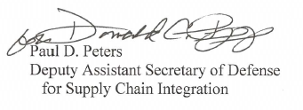

Paul D. Peters
Deputy Assistant Secretary of Defense
for Supply Chain Integration

