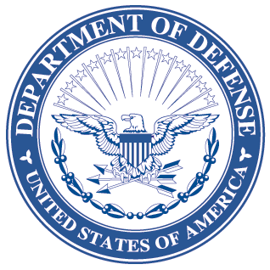
OFFICE OF THE ASSISTANT SECRETARY OF DEFENSE
3000 DEFENSE PENTAGON
WASHINGTON, DC 20301-3000
LOGISTICS AND
MATERIEL READINESS
DLM 4000.25, Volume 6, May 4, 2018
Change 10

DEFENSE LOGISTICS MANAGEMENT STANDARDS
VOLUME 6, Logistics Systems Interoperability Support Services
CHANGE 10
I. This change to DLM 4000.25, Defense Logistics Management Standards (DLMS),
Volume 6, June 5, 2012, is published by direction of the Deputy Assistant Secretary of Defense for Supply Chain Integration under the authority of DoD Instruction (DoDI) 4140.01, “DoD Supply Chain Materiel Management Policy,” December 14, 2011. Unless otherwise noted, revised text in the manual is identified by bold, italicized print. Exceptions are when an entire chapter or appendix is replaced, a new one added, or an administrative update is made. Administrative updates in Change 10 include the following: Abbreviations such as etc., e.g., and i.e. are incorporated inside the parentheses. Occurrences of “shall” are changed to “will” per a style change for DoD issuances. References to “(DLA) Transaction Services” are changed to “Defense Automatic Addressing System (DAAS)” and “DLA Logistics Information Services” to “Logistics Information Services”. In addition, minor typographical and similar editing errors in previous versions have been corrected.
II. This change includes Approved Defense Logistics Management Standards (DLMS) Change (ADC) published by Enterprise Business Standards Office memorandum:
A. ADC 1025F dated November 29, 2017. Updates the Component routing identifier codes (RICs) LMARS uses to generate reports. These RIC changes are routine, periodic updates provided by the Component PM PRC representatives. The tables are linked from Chapter 4.
B. ADC 1151 dated September 14, 2107. Removes references to specific record retention periods for documents/transactions, and advises the Components to retain data created as a result of DLMS business processes in accordance with the DODI 5015.02, DOD Records Management Program. Revises Chapter 4.
C. ADC 1270 dated September 19, 2017. Adds and implements the HB Series of DoDAACs for United States Cyber Command (USCYBERCOM). No changes to manuals required for this change.

III. The list below identifies the chapters, appendices, or other files from the manual that are replaced by this change:
Added or Replaced Files
Change History Page
Chapter 4

IV. This change is incorporated into the on-line DLM 4000.25 series of manuals and the PDF files containing the entire set of change files on the publications page of the Defense Logistics Managements Standards Website: www.dla.mil/does/dlms-pubs

