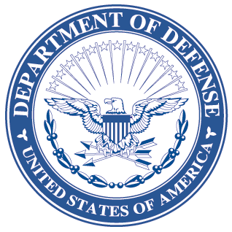
OFFICE OF THE ASSISTANT SECRETARY OF DEFENSE
3000 DEFENSE PENTAGON
WASHINGTON, DC 20301-3000
LOGISTICS AND
MATERIEL READINESS
DLM 4000.25, Volume 6, June 16, 2015
Change 5
DEFENSE LOGISTICS MANAGEMENT STANDARDS
VOLUME 6, Logistics Systems Interoperability Support Services
CHANGE 5

I. This change to DLM 4000.25, Defense Logistics Management Standards (DLMS),
Volume 6, June 2012, is published by direction of the Deputy Assistant Secretary of Defense for Supply Chain Integration under the authority of DoD Instruction (DoDI) 4140.01, “DoD Supply Chain Materiel Management Policy,” December 14, 2011. Unless otherwise noted, revised text in the manual is identified by bold, italicized print. The exception would be when the entire chapter or appendix is replaced, or a new one added. Change 5 also includes administrative updates not marked by bold italics, to include changing “shall” to “will” per a style change for DoD issuances and updating “Defense Logistics Management System” to “Defense Logistics Management Standards.”
II. This change includes Approved Defense Logistics Management Standards (DLMS) Change (ADC) published by Defense Logistics Management Standards Office memorandum:
- ADC 1025B dated February 7, 2014. Updated U.S. Air Force Routing Identifier Codes (RICs) used to generate reports in LMARS. No changes to the manual.
- ADC 1098 dated November 7, 2014. Updated the DD Form 1348-5, Notice of Availability; updated the DLMS 856N NOA and DLMS 870N NOA Reply to align with the hard copy data content of the DD Form 1348-5; established the foundation for a mechanized implementation for the NOA process to provide the International Logistics Control Office (ILCO) visibility; and updated procedures for ensuring timely replies to NOAs by actively engaging the ILCOs when there is no response to a follow-up NOA. Revises Chapter 3.
- ADC 1100 dated April 17, 2014. Allocated the HGA series to USTRANSCOM Acquisition for tracking contractor DoDAACs. No changes to the manual.
- ADC 1101 dated May 19, 2014. Allocated the DoDAAC series H96 to US Northern Command (USNORTHCOM). H96 will not be authorized for creating contractor DoDAACs. No changes to the manual.
- ADC 1117 dated July 2, 2014. Improved and refined the business rules associated with the type address codes (TAC) used in the DoDAAD and removes TAC 4. This change is not applicable to DoDAACs already resident in the DoDAAD, but will apply to any future changes made to existing DoDAACs or when new DoDAACs are created after the implementation date of this change. Revises Chapter 2.
III. The list below identifies the chapters, appendices, or other files from the manual that are replaced by this change:
Added or Replaced Files
Change History Page
Table of Contents
Chapter 2

Volume 6, Appendix 1.1
Chapter 3
Chapter 4
IV. This change is incorporated into the on-line DLMS manual at the Defense Logistics Managements Standards Website Publications Page and the PDF file containing the entire set of change files is available on the Formal Changes Page.

