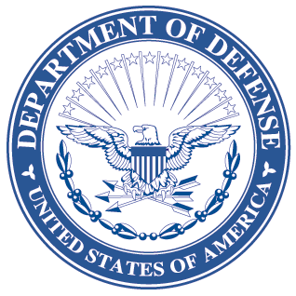
OFFICE OF THE ASSISTANT SECRETARY OF DEFENSE
3000 DEFENSE PENTAGON
WASHINGTON, DC 20301-3000

LOGISTICS AND
MATERIEL READINESS
DLM 4000.25, Volume 6, June 25, 2013
Change 2
DEFENSE LOGISTICS MANAGEMENT SYSTEM
VOLUME 6, Logistics Systems Interoperability Support Services
CHANGE 2

I. This change to DLM 4000.25, Defense Logistics Management System (DLMS), Volume 6, June 2012, is published by direction of the Deputy Assistant Secretary of Defense for Supply Chain Integration under the authority of DoD Instruction (DoDI) 4140.01, “DoD Supply Chain Materiel Management Policy,” December 14, 2011. Unless otherwise noted, revised text in the manual is identified by bold, italicized print. The exception would be when the entire chapter or appendix is replaced, or a new one added.
II. This change includes Approved Defense Logistics Management System (DLMS) Changes (ADC) published by DLA Logistics Management Standards Office memorandum:
- ADC 448A dated October 2, 2012. Approved Addendum, Address Line 5 Country Name Implementation and related DoDAAD Batch Transactions. No change to manuals or DLMS Supplements.
- ADC 448B dated October 2, 2012. Delayed implementation for International Organization for Standardization 3166-1 Codes for the Identification of Countries and their Subdivisions. Revises Chapter 3.
- ADC 1025 dated 12 September 2012. Update to Routing Identifier Codes, DoD Activity Address Codes, Reparable/Non-repairable National Item Identification Numbers, combatant Command designations in the Logistics Metrics Analysis reporting System. Revises Chapter 4 (file linked from C4.6.3.1.2, Table D, Inventory Control Points).
- ADC 1025A dated February 6, 2013. Addendum to Update of Routing Identifier Codes, DOD Activity Address Codes, Reparable/Non-reparable National Item Identification Numbers, and Combatant Command designations in the Logistics Metrics Analysis Reporting System. Revises Chapter 4. (file linked from C4.6.3.1.2, Table D, Inventory Control Points).
- ADC 1038 dated September 11, 2012. Update of Logistics Metric Analysis Reporting System (LMARS) Fill Rules. Revises Chapter 4.
III. The list below identifies the chapters, appendices or other files from the manual that are replaced by this change:
Added or Replaced Files
Change History Page
Table of Contents
Chapter 3
Chapter 4
IV. This change is incorporated into the on-line DLMS manual at the Defense Logistics Managements Standards Website Publications Page and the PDF file containing the entire set of change files is available on the Formal Changes Page.

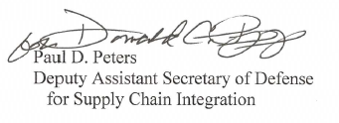

Paul D. Peters
Deputy Assistant Secretary of Defense
for Supply Chain Integration

