Changes to the DD1155 from EBS

1. The change is based on Defense Procurement Acquisition Policy (DPAP) Procurement Data Standard (PDS). When providing FOB details, Payment Method is mandatory.

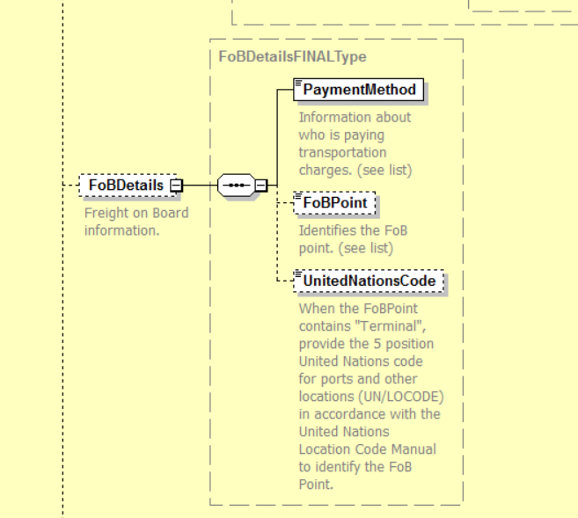

*screenshot pulled from 2.5.1 PDS schema on the DPAP website. Solid lines mean it is mandatory. https://www.acq.osd.mil/dpap/pdi/eb/docs/PDS_Picture_Award_CLIN_CDRL_v2.5.1.png

1. Users will start to see FOB Payment Method on the 1155 continuation page after the FOB Point
2. If FOB point is Origin then the FOB Payment Method will be set to Government

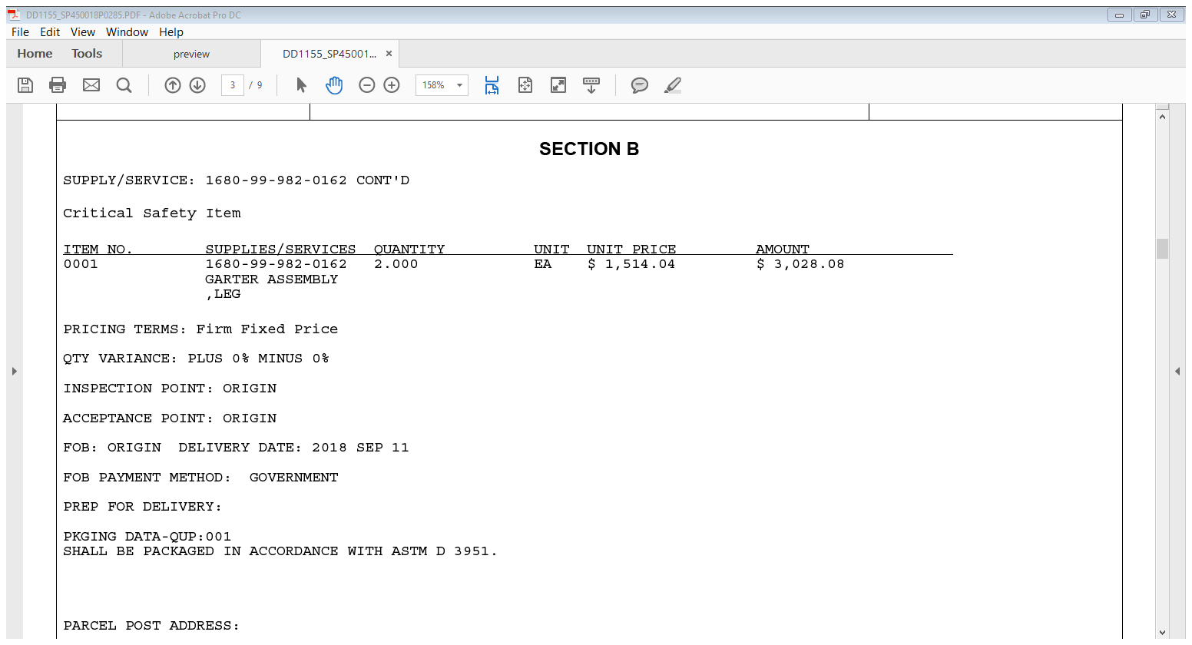

1. If FOB point is Destination then the FOB Payment Method will be set to Contractor

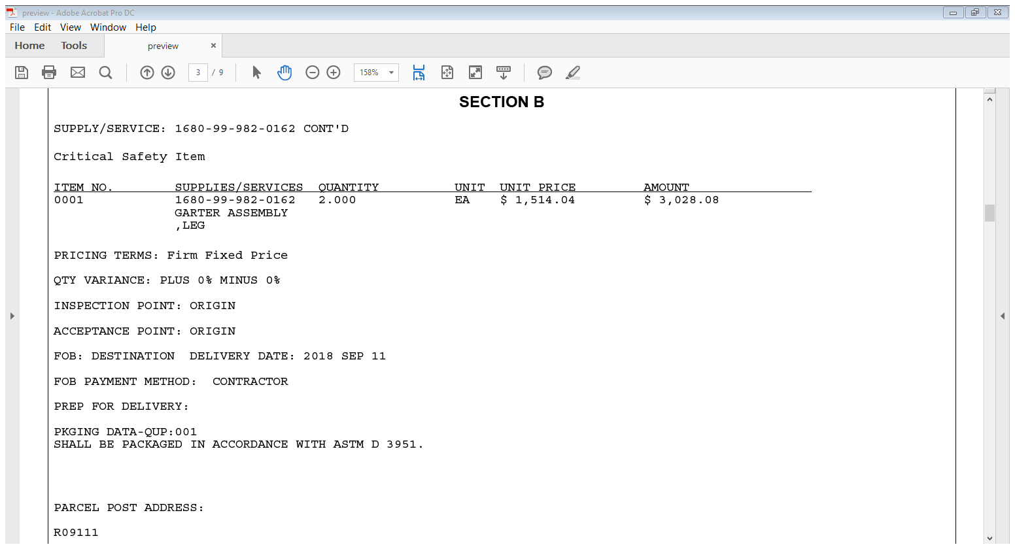

1. If there is not FOB point then the FOB Payment Method will not print

